A Vision for Urban Growth and Recovery

Purpose of report
For direction.

Summary
This report sets out some of the headline issues affecting urban areas and proposes that the Board commission a piece of research to explore how these might be responded to.

Recommendation
That the City Regions Board consider the context set out below and agree to the commissioning of external research to support the development of a vision for urban growth and recovery.
Action
Officers to proceed as directed by members.

Contact officer: Ellie Law
Position: Adviser
Phone no: 0207 664 3164
Email: Eleanor.Law@local.gov.uk

A Vision for Urban Growth and Recovery
Background
- The last six months have had a profound impact on the people and places of the UK, with an unprecedented level of social and economic disruption that looks set to continue well into the next year.

- While there continues to be a significant degree of uncertainty regarding the course of the global coronavirus pandemic there is an emerging consensus that communities in urban areas have borne the brunt of the economic lockdown and stand most exposed to any future waves of infection.

- Research previously commissioned by this Board has articulated some of the key factors contributing to additional cost pressures in urban areas – a separate item on the agenda looks at these in more detail. Recent estimates have also highlighted a link between geography and mortality, with evidence suggesting significantly more people have died as a result of COVID-19 in larger towns and cities.

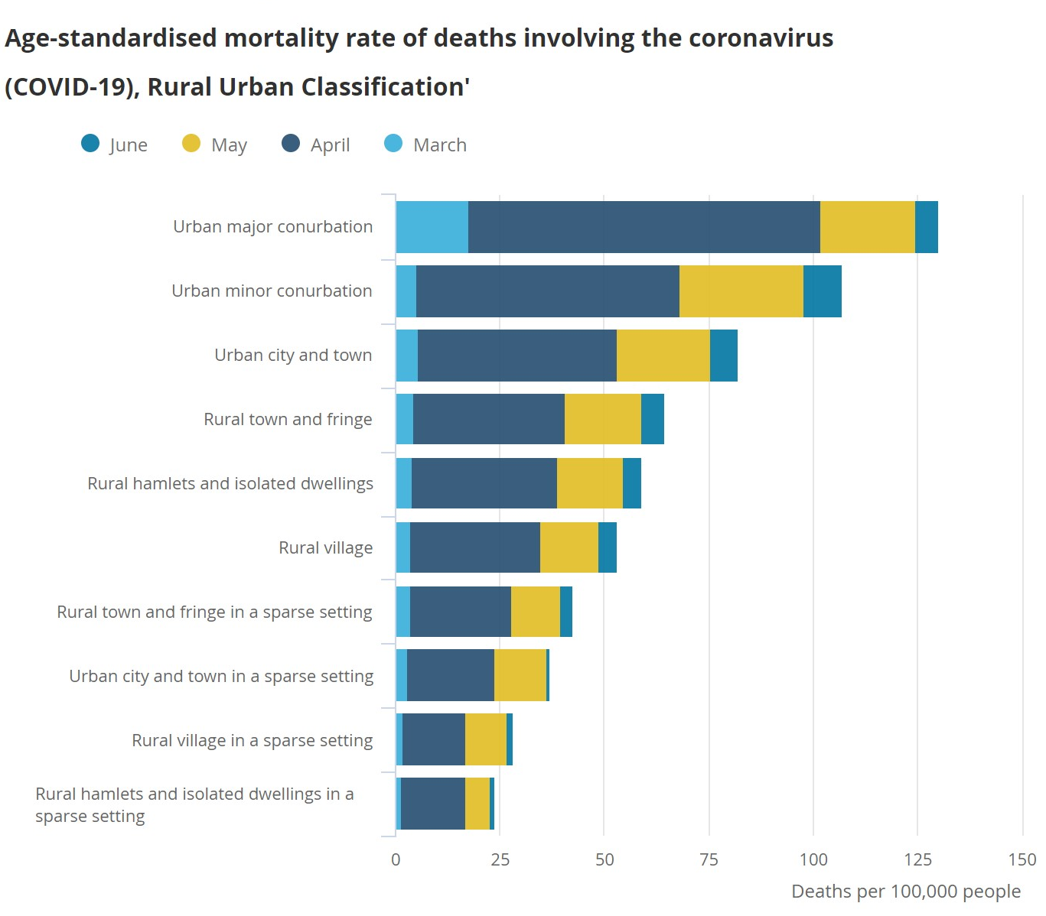
- It is likely that cities and urban areas will face challenges in recovery owing to high levels of population density, a reliance on mass public transport, changes in working patterns and the continued risk of household and visitor transmission.

- Analysis by the Office for National Statistics also indicates that COVID-19 has had a disproportionately higher impact on people living in deprived areas. The greatest concentrations of inequality are to be found in urban areas.

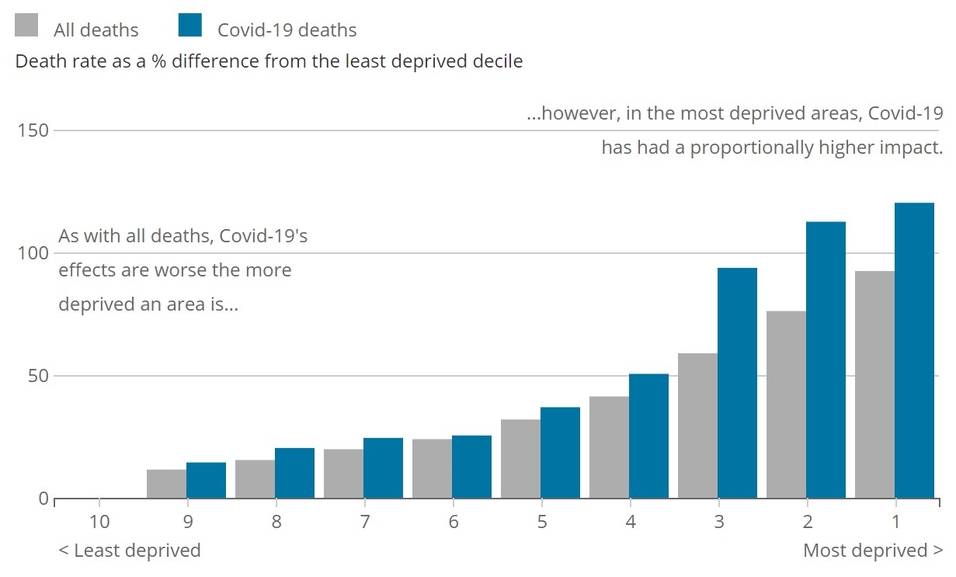

- The UK economy is built around concentrations of activity in urban areas. This is supported by long-standing evidence highlighting the benefits of economic agglomeration as a driver of growth and global innovation. Cities are also home to significant levels of cultural and economic capital and, more importantly, communities made up of millions of people.

- These communities have shown exceptional levels of resilience and courage throughout the pandemic. As the initial focus on emergency response has developed, local leaders have begun to turn their focus from the immediate crisis to the securing a return to their future prosperity.

- Authorities have been developing recovery plans, which outline their strategies and goals in rebuilding post pandemic. Although each area is unique, and the recovery plans reflect this, there are several common themes. A full recovery requires a return to economic growth, and authorities are best placed to lead this work, which is reflected in recovery plans.

- Authorities do not want recovery to mean exactly replicating previous conditions. Instead, there is a thread running through many recovery plans around building back in a sustainable way, with an emphasis on green growth. COVID-19 has shown how agile and responsive local government can be in an emergency, and this ability to adapt at pace could be used to respond to the climate emergency.

- Along with local recovery plans, central government has convened four officer-led task and finish groups to consider different areas of recovery: visitor and rural economies; urban economies; skills; and, business innovation. The LGA has played a supporting role and worked alongside these groups to help focus their asks of government. However, while the output from these groups will be considered by the ministerial recovery board, they have been independently chaired and sit outside the member-led policy development structure of the LGA.

- Broadly speaking, the short term asks from both local recovery plans and nationally convened taskforces have focussed on increasing financial support, and for greater involvement in decision making bodies on recovery. Longer term asks are centred on looking for opportunities for sharing of information, skills and expertise.

- Local government has the ambition to lead a local recovery and ‘build back better’ for the benefit of communities and businesses, but it needs support to do this most effectively. There needs to be both additional funding, and clarity about how local government will be funded long-term. The government also needs to unlock the potential for greater collaboration – both between authorities and between local government and business, research and innovation sectors.
Issues
- The City Regions Board has a key responsibility to consider the immediate issues facing urban areas and help chart a course towards an ambitious vision for recovery and renewal. It also has a vital role in allowing local leaders from urban authorities to collaborate and explore issues of shared concern on a national stage with a pace and perspective that reflects the long-term implications arising from the impact of coronavirus.

- While suggestions of the whole-sale de-urbanisation UK economy are likely to be overblown, it would be unwise to entirely discount the possibility that changes in working patterns will undergo a complete reversion. Equally, the coronavirus pandemic has exposed issues of inequality affecting urban areas as well the opportunity for pursuing a model of growth that addresses aspects of social and economic justice, while looking ahead to the UK’s future prosperity outside the European Union. Put simply, it is difficult to predict how the next few months will pan out and there is a need for elected members to have some space and support to consider how best to respond to the unfolding situation.

- To this end, it is proposed that the City Regions Board supports the commissioning of external support to gather qualitative and quantitative evidence and facilitate the development of a Vision for Urban Growth and Recovery, with the intention of a report being published in late spring, early summer 2021. Where possible this work will draw on the evidence already provided through Local Industrial Strategies, Local Recovery Plans and national policy announcements.

- If members are agreed to this course of action, it is suggested that the following areas are used to frame the scope and scale of the commission:

  - Recognise and respond to the distinct inequalities facing urban areas that have been exposed by the coronavirus pandemic.

  - Take account for the spatial and demographic factors that might constrain or enhance future opportunities for urban recovery and growth

  - Reflect on developments affecting the global economy and the role of technology in connecting urban communities and businesses to these opportunities

  - Quantify the benefits and/or opportunity cost of failing to fully support the future prosperity of urban areas

  - Identify the key interventions and the most appropriate institutions for their execution.
Next steps
- The City Regions is asked to consider and agree to the proposal to commission external support focused on the development of a vision for urban growth and recovery.

Implications for Wales
- The LGA has worked closely with the Welsh Local Government Association and the associations of the other devolved administrations throughout the coronavirus pandemic and will continue to do so through the process of recovery.
Financial Implications
- Project costs related to the commissioning of any external support will be met from the board’s policy budget.

ONS Statistical Bulletin July 2020
ONS Statistical Bulletin July 2020

